LOGIC ADVISORS LOGIC ADVISORS LOGIC ADVISORS LOGIC ADVISORS LOGIC ADVISORS LOGIC ADVISORS
LOGIC Advisors ©

07/21/2020

GOLD ROARS TO NEAR NINE-YEAR HIGH, SILVER TO BEST LEVELS SINCE 2014.
EU RESCUE PLAN TOTALS $2.1 TRILLION. U.S. PLAN IS NEXT.
EURO EXTENDS GAINS. STOCKS ADVANCE ACROSS THE BOARD.
TECH LOOKING GOOD.

Metals: It was a big day for precious metals as gold, silver and PGM's all achieved solid gains after the EU agreed on a rescue plan of $2.1 trillion and a Coronavirus relief plan. The EU ended four days of difficult negotiation with a strong result. A U.S. stimulus package is also in the works and we suspect and agreement might be achieved by early August. Gold had been holding in a range over $1,800 and then exploded through that area with a $26.50 advance to $1,834.90. The market was solid all session and leaves us holding longs with a $1,900 objective. A weaker US Dollar also contributed to the rally. September silver also had a good day as surged to its best levels since July 2014, gaining $1.37 to $21.55. We are only officially hold long gold positions but retain our bullish outlook for silver which is on a surge. PGM's were not left out with October platinum and September palladium gaining ground. Our view is to hold long palladium while we are standing aside platinum but that also looks headed higher. Goldman upped its forecast for gold to $2,000 today. Market should work higher through September.
August 2020 Gold Futures
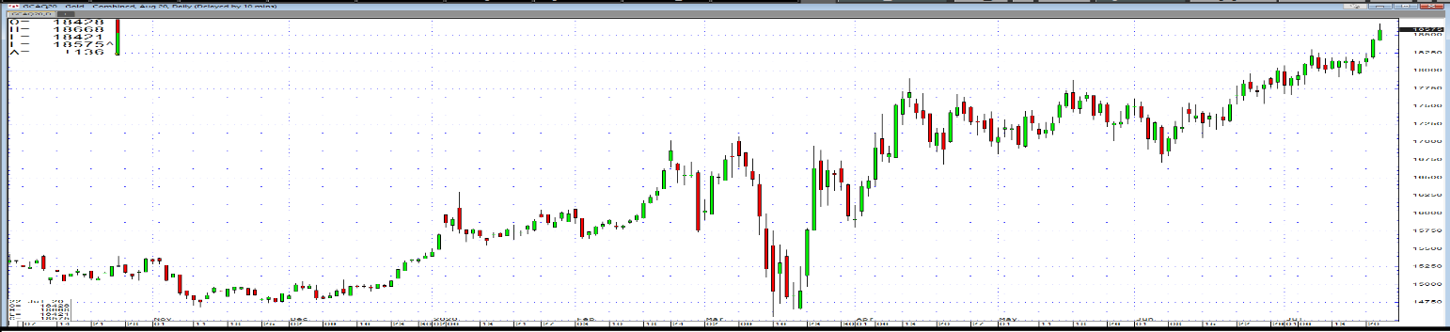
September 2020 Silver Futures
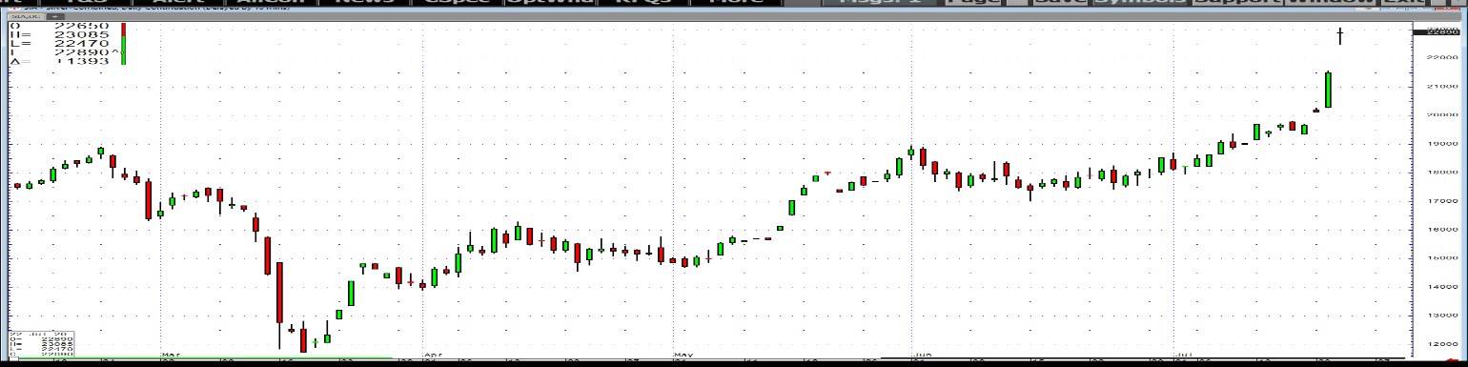

Currencies: Our bullish view for the Euro is playing out as the currency responded to the above EU agreement. In late action the Euro was up 60 cents to $1.1508 with dealer buying active. Further gains are likely for the currency and technical indicators have broken out to the upside. Pound Sterling is following with a 77-cent gain to $1.2737. We see the Pound beginning to reflect some improvement in the UK Coronavirus crisis and expect it to also work higher. The Japanese Yen was down 47 to 106.80 as its role as a protective currency was reduced. However, don't look for too much downside for this narrow range vehicle. The Australian dollar jumped 96 cents to 71.12 and our 72-cent target is on track. Australia is doing better than most in the virus fight. Perhaps as high as 74 cents might be in order here. The US Dollar Index fell 0.62 to 95.12 and is in a clear downtrend.
LOGIC ADVISORS LOGIC ADVISORS LOGIC ADVISORS LOGIC ADVISORS LOGIC ADVISORS LOGIC ADVISORS
Global Equities: European stocks had a good day with the broad Stoxx 600 rising 1.19 to 376.70. The EU agreement on a rescue plan was the leading driver of the rally. France's CAC rose 11 to 5,104, Greece was 17 higher at 7,495 and the UK's FTSE advanced 8 to 6,270. We retain advice for longs in the European sector with Germany the most favored.
Asian stocks were big winners today including 578-point gain to 25,639 for Hong Kong. The Chinese government has been supporting this index and it has responded with a strong rally. Further gains seem probable. Korea's Kospi has also been on a roll as it advanced 31 to 2,239. This index has roared back from a 1,439 low and also seems to have further potential. Shanghai advanced 7 to 3,321 and Singapore was up 13 to 2,629. Overall, Asia has an upside bias.
U.S. stocks scored gains with the Dow rising 160 to 26,841. The first half of the session saw the greatest strength and second half was kind of mixed but all things considered prices held reasonably well. Nasdaq lost and the S&P rose 5 to 3,257. Not exactly a roaring day but the European agreement lent support and sets thing up well. The SP close was the highest since Feb 21 so we are moving in the right direction. Interestingly, options players are skewing in the right direction. There is some optimism expressed by corporate leaders that the first quarter may well represent the bottom. Earning's reports have been decent including IBM yesterday and Texas Instruments this afternoon.
Stay long U.S. stocks.
Interest Rates: European rates included the German 10-Year at minus 0.457% from minus 0.475% and Italy at 1.083% from 1.093%. Greece stood at 0.367% from 0.355% and the UK at 0.137% from 0.152%. Rates reflected the agreements on EU policy. Mike Pompeo was visiting the UK today to work on some agreement. The UK seems to be gradually recovering from the Coronavirus crisis but still has a long way to go.
Treasury yields were lower again today with the 10-Year note at 0.602% from 0.615%. The 2-Year note was at 0.143% and the 30-Year was at 1.306%. Economic data was light with only the Chicago Fed National Activity Index at 4.11 from 3.50, a decent number but not really a market mover. Pressure was on all day and yields were lower as the Fed is expected to follow the EU with stimulus in the near term which is pressuring bond yields. The direction of bond yields is lower at present with government activity paying a major role. We have been saying yields were bottoming but recent evidence puts such a forecast in doubt.
Energy: September WTI crude oil rallied $1.00 to $41.92 and this market looks headed still higher. We have a $43 objective for our recommended longs but see $45 as possible. OPEC has been doing a great job in keeping output at reasonable levels and appears in good shape at least through September. Demand is improving, particularly in Europe and the U.S. and looks headed for further gains. Tomorrow is DOE inventory day with the consensus calling for crude stocks to decline by 1.9 million barrels. We are retaining our bullish bias.

The CRB Index was down 14 to 149.42 yesterday. It has fallen 20.3% year to date and has risen 1.19% in the past month. We have a bullish bias at these levels. Keep the faith!

BILL O'NEILL
201-314-3854

Bill O’Neill/Ron Lawson
Lawson/O’Neill Global Institutional Commodity Advisors, LLC
www.logicadvisors.com
Trading in futures and options on futures is not appropriate for all persons, as the risk of loss is substantial. Therefore, except for those considered to be bona fide hedgers, only risk capital should be used in futures trading. Information contained herein is based on reports or communications or other sources believed to be reliable. Neither the information contained herein nor any opinion expressed shall be construed to constitute an offer to sell or a solicitation to buy any securities mentioned herein. The content of this letter is the Copyrighted property of L.O.G.I.C. Advisors, LLC. 2020-07-21

This Letter may not be replicated, in part or in whole, without prior written permission of its authors.

